 in cooperation with 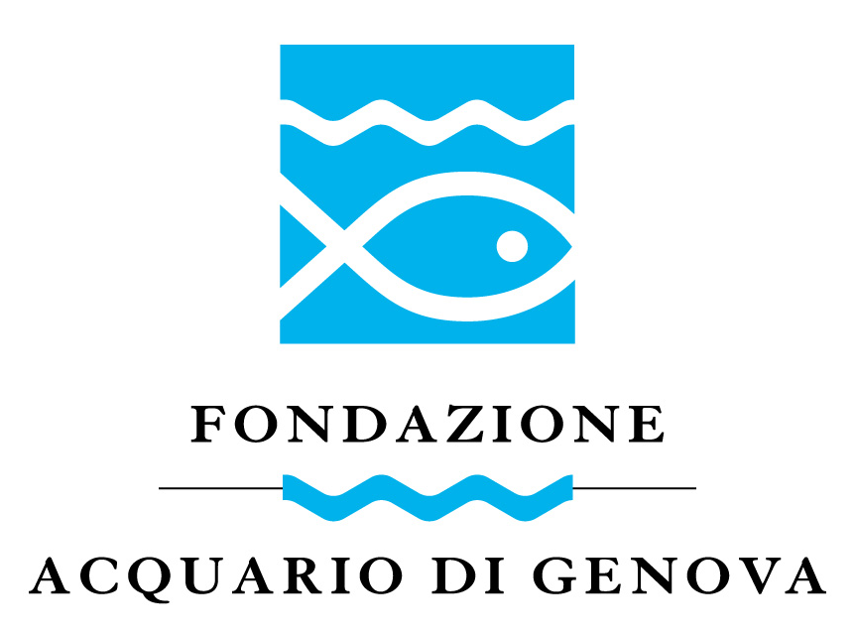

THE MOTHER-OF-PEARL PROJECT

ENVIRONMENTALLY FRIENDLY AND SOCIALLY INCLUSIVE 2006

INTRODUCTION

Mother-of-pearl is one of the natural materials that has been used by man for ornamental purposes since the dawn of time. Its iridescence catches the eye and creates a point of interest on both objects and clothing.
Like all ornaments, it is not indispensable, but its use is part of human culture and has been a tradition since ancient times.
Mother-of-pearl is mainly obtained from a wide variety of Mollusc species, belonging to the Lamellibranchs (bivalves), Gastropods and also Cephalopods.
The species most commonly used for the highest quality mother-of-pearl, where the layers of aragonite crystals overlap in such a way as to create a pearl-like, uniformly coloured but fascinatingly translucent whole, are predominantly Gastropods, with shells characterised by their robust thickness. Among these, species are favoured where the layers of aragonite prevail over the (opaque) layers of calcite, which are present on the inside of the shell. The genus offering the thickest mother-of-pearl with a fairly uniform colour is Trochus, an herbivorous gastropod found throughout the planet's temperate and warm seas. Within this genus, the species that are chosen for the production of fine mother-of-pearl are those found in the tropical and circumequatorial zones of the oceans, with a clear predominance of the species Trochus niloticus, whose spirals are less rounded than others, allowing the creation of high-quality, thick buttons.

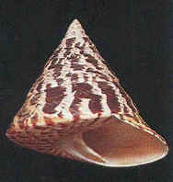 1 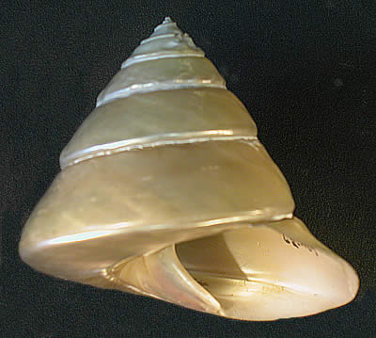 2 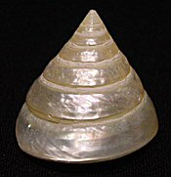 3

Shell of Trochus niloticus: natural appearance (1) and with the mother-of-pearl layer exposed (2 and 3).

Mother-of-pearl with its shimmering colours and high iridescence, most commonly used for fashion accessories and jewellery, comes mainly from gastropod molluscs of the genus Haliotis and bivalve molluscs of the genus Pinctada, which all have a distribution overlapping that of Trochus.
Haliotis is an herbivorous gastropod. The most commonly used species are the large Haliotis rufescens and Haliotis fulgens, of which the big foot muscle is also used for edible purposes.
Pinctada is a bivalve most commonly known by the common name of pearl oyster, as the most commonly used species is precisely Pinctada margaritifera, which is also capable of producing pearls of excellent quality. Pinctada mother-of-pearl is mainly used as a by-product of pearl production in some localities.
Lower-quality mother-of-pearl is also obtained from other freshwater bivalves, particularly those of the genus Unio, widespread in most of the major rivers on the planet. Among the cephalopods, mother-of-pearl is only obtained from the shells of the genus Nautilus, but in that case the decorticated shell becomes an interior object itself.

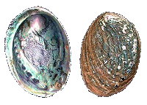 1 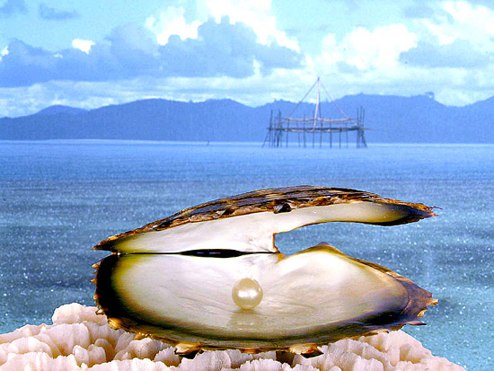 2

Shell of genus Haliotis sp. (1) and Pinctada margaritifera (2).

For many developing countries, the trade in mother-of-pearl shells constitutes an important (sometimes even prevalent) economic component for coastal communities, which in some cases also use the soft parts of shellfish for local food purposes.
Having an idea of the overall production of mother-of-pearl shells is rather difficult, since a part of the production flows escape detection, being used by local communities or put on the market in various forms.
The total production is around a few tens of thousands of tonnes, but a table in the 1990s gave the following figures for the Pacific area, limited to Trochus:

Area | tons
Pacific Islands | 2300
Indonesia | 475
Philippines | 200
Okinawa | 200
Australia | 500
Minor sites | 225
Total | 3900

To these productions must also be added those from the Red Sea and Indian Ocean, which are likely to reach, in total, a similar figure (Sudan alone produces around 700 tonnes per year of Trochus).
Much of the production is of wild origin, while only for the past few years has there been breeding production, the quantities of which are not available.
Much of the production is processed on-site (percentages vary from about 5% in Micronesia to 94% in the Solomon Islands), resulting in both finished and semi-finished products for more valuable end processing.
The amount of the commercial value at the first level of a production assumed to be about 20000 t. should be around $11 M per year minimum, while it is very difficult to obtain the final commercial value of the production, given the weight losses during the processing of the products and the extreme differentiation of the finished products.

THE NATURAL RESOURCES

The stocks of the various species used for the production of mother-of-pearl are generally poorly known and, in general, their original abundance is unknown. From a scientific and resource management point of view, the exploitation of the various stocks and populations has always been initiated without a prior assessment of the resource, so that it is now very difficult to assess the extent of the exploitation status and, consequently, the value of B_{msy} and F_{msy}, which are decisive factors in establishing the sustainability of the harvest in the wild.
In fact, harvesting has been carried out, in most cases, by progressively exploiting the different species, starting with the areas most in proximity to the local communities concerned and progressively extending the range on the basis of continued harvesting success.
Only recently, in some areas, such as Australia, the Federation of Micronesian States, French Polynesia and Japan, have management mechanisms been introduced to regulate harvesting.
In various parts of the ocean, tropical coral reefs have undergone a progressive depletion of natural resources related to mollusc species necessary for mother-of-pearl production, either through direct harvesting or through effects resulting from alterations in ecosystems, also due to different environmental factors (climate changes, seawater warming, coral bleaching, silting up of some reefs, alteration of biocenotic relationships, etc.).
The situation is much better as far as Pinctada is concerned, since it can take advantage of the existing pearl-producing farms in several locations, mainly in the Pacific area, while Trochus breeding facilities exist only in the Pacific islands and consist of less than twenty farms.
The planning of breeding activities with no or very low impact on the various wild species thus becomes a fundamental element for the future of this sector, given the unsustainability of current management in the long term. The creation of eco-sustainable and supportive breeding projects is an additional necessity and a collective and individual responsibility.

In situ observations

Both gastropod molluscs of the genus Trochus and bivalve molluscs of the genus Pinctada occur naturally in most of the coral beds of the coastal area of Khanh Hoa Province (Vietnam).
The natural stocks of both genera appear to be rather overexploited, although there is a total lack of scientific data on this. In fact, a distinction must be made between the various species, as the situation is quite differentiated.
With regard to Trochus niliticus, the most commercially used species, both for mother-of-pearl and as a souvenir, the situation is rather compromised in most of the province's coral reefs. Larger specimens are becoming increasingly rare, while the stock suffers heavily from the fishery made over the past decades.
The other Trochus species present in the area (T. acutangulus, T. calcaratus, T. concavus, T. cornutus, T. dentatus, T. incrassatus, T. maculatus, T. maximus, T. pyramidis, T. radiatus, T. sandwichensis, T. tectus, T. telescopium, T. verrucosus, T. virgatus) are distributed differently. From the information obtained, it appears that for several of these species of minor commercial interest the stocks are still in an acceptable condition, while for others (such as T. pyramidis) the situation shows clear signs of overexploitation and rarefaction.
As regards pearl oyster species of the genus Pinctada, here too it appears that the natural populations are all over-exploited, with an increasingly reduced size of specimens, while the situation seems to be particularly deteriorated in the areas most affected by anthropogenic coastal pollution.
The distribution of coral reefs in the area of Khanh Hoa Province, according to information provided by the Institute of Oceanography in Nha Trang, includes between the coast and the islet of Hon Noi, a series of reefs and platforms in the area immediately SE from Nha Trang, near the islands of Hon Mun (the planned Marine Protected Area) and Hon Tam, a large reef between the coast and the islet of Hon Dun, E-NE from Nha Trang, a large coral shelf in the terminal area of the peninsula of Ha Ninh Phu near the village of Ninh Van, a series of reefs near Hon Do and Hon My Giang, a very compromised reef near the coast in front of the village of Dij Giang and the shipyard of Da Lat, several reefs in the SW and NW of the large island of Hon Lon, other coral reefs near the islet of Hon Doi, on the outer side of the peninsula of Ban Dao Hon Gom. Fairly intact, however, are the coral islands of the QD Truong Sa archipelago, located more than 500 km SE of Nha Trang. Coral banks are also reported in Vung Ra Bay, Phu Yen Province.

In the area of the Xa Ninh Phu peninsula, Dam Nha Phu Bay presents a peculiar hydrographic situation, conditioned by the orography of the area, the wind regime and the granulometric characteristics of the seabed. In the vast bay are the islets of Hon Lao and Hon Thi (Monkey Island), plus other smaller islets.
The shallow waters of the most coastal and southern area are strongly affected by both the inputs of organic pollutants from Nha Trang and the movements caused by the winds, when these blow from the southern quadrants. During the survey, a periodic wind, which begins to blow daily between 12.30 and 13.00, was detected coming from the S-SE and causing a mixing of the waters of the bay, lifting the finest sediments from the seabed.
This very high water turbidity obviously causes problems for the coral reefs, which appear rather deteriorated and depleted. The presence of an important fraction of fine-grained sediments within the bay is confirmed by the significant population of bivalves of the genus Scapharca.
This is almost certainly the cause of the relocation of a pearl oyster farm, which had been located in the vicinity of Hon Thi. Instead, a lobster farm still exists, divided into two installations.
In the furthest part of the Xa Ninh Phu peninsula, near the village of Ninh Van, the waters maintain a greater transparency, confirmed by the evident state of good conservation of the coral platform that characterises the shallow waters in front of the village, where a sort of reef with a small pass even exists. In spite of the evident state of exploitation of the coral reef, the biodiversity is clearly greater than in the innermost part of the bay, and the reef itself does not appear to be in any way compromised in its madreporic components, while the fish populations appear conspicuously depleted. Several species of Trochus, Pinctada and Pteria are still naturally present here, as evidenced by specimens on the stranded on the shoreline.
At the base of the mountain relief with which the peninsula ends (813 m above sea level), the small fishing village (including many shell fishermen) is particularly neat and tidy, lively and extremely dignified.
As for the exposure of the end zone of the peninsula and the very small bay of Cay Ban (where the village of Ninh Van is located), this appears to be protected from the strong monsoon swells (which, on the other hand, should affect the part of the coral reefs at the NE side of the peninsula), while theoretically it should be exposed to the very long fetch from the SE, which should cause large waves. In reality, however, these appear to be rather rare and the islets of Hon Dung, Hon Yen, Hon Bac and Hon Cha La contribute to a sort of natural obstacle, albeit a discontinuous one. This hypothesis is also confirmed by the good state of maintenance of the beach in front of the village of Ninh Van and the proximity of the local dwellings to the tide line (which would otherwise not be conceivable in the case of strong swells). The large area of shallow water in front of the end of the peninsula also contributes to dampening the force of the fetch.

The second area considered is the large bay of Vinh Van Thong. Here there are two main areas of some interest.
The first is located along the NE side of the Xa Ninh Phu peninsula, i.e. in the SW part of the bay. Here, in the vicinity of Ninh Thuy there is a large shipyard, mainly used for ship repairs, which is potentially a source of pollution for the area. In the innermost part of the bay, in the coastal stretch of Vung Hon Khoi, there are numerous shrimp farms. This fact is significant, as it results in massive nutrient pollution, which is not buffered by the mangroves, whose population appears extremely small and depleted. The shallow waters of the area and the freshwater inputs could favour the development of algal blooms, with subsequent problems of oxygen depletion. Salinity changes due to freshwater inputs from the Sang Hau and Suoi Binh Trung rivers, which flow into the central part of the bay and which, during the rainy season, are able to significantly influence coastal water density, must also be considered.
In front of the islets of Hon Kho, Hon Theo, Hon Heo and Hon Hoa lies a large village, which is also home to numerous fishers, only a few of whom engage in shellfish harvesting. Here, the relationship with the surroundings is not optimal and the village also has a shabby appearance, with a very dirty beach. The state of the coral reef appears impoverished in biodiversity and very overexploited in its main components.
Very different is the situation in the northern part of the large bay of Vinh Van Tong, which is characterised by a very peculiar orography. The part towards the NE consists of a long peninsula oriented S-SE. Between the mainland and the extreme part is a long sandy dune belt, which is particularly interesting on the side facing the open sea. The tormented-looking end of the Ban Dao Hon Gom peninsula is characterised by two noteworthy heights: the first, on an inland arm, is 436 m, the second, towards the extremity, is 309 m.
The peninsula, on the inland side, faces the long island of Hon Lon, with a relief of 567 m, thus delimiting a longitudinal stretch of sea, widened in the middle and rather deep, which communicates with the open sea via the Lach Cua Bo, a kind of natural channel. In the rather deep inland sea are the islets of Hon Ong, Hon San, Hon Mai and several smaller islets, while the inland coasts are dotted with numerous fishing villages and the settlement of Vinh Van Phong.
Several economic activities are currently concentrated in this part of the bay: there is a 1-hectare tourist settlement, a lobster farm of about 200 hectares, a pearl oyster farm (Pearl Vietnam Co. Ltd) of about 100 hectares, and a small port for the export of sand, which handles about 100 tonnes annually. This concentration of activities confirms the capacity and potential of this area, which is certainly special and interesting.
However, it is precisely the characteristics of the area and the existence of this 'inland sea', so well protected from any factor and insidiousness, thanks to the relief of the peninsula and the island in front of it, that have led to various ideas for new projects, investments and settlements flowing into the area.
In fact, work is already in progress on a series of new tourist settlements, especially along the beautiful outer dune cordon, which should serve to launch the area touristically. At the same time, there are plans to significantly expand mariculture facilities for oysters and lobsters and to build new ones. The biggest problem is the fact that the government has submitted a project to build Vietnam's largest container port right in the inland sea, apparently in the Vinh Van Phong area. If the project were to materialise, this would entail a massive revolution in the existing land routes, with the widening of existing roads. This would have as a direct consequence a number of problems on the tourist settlements currently being developed, due to the heavy traffic that would be created and the limited width of the dune cordon that would connect the port to the coastal highway. In addition, a port of significant size would certainly lead to problems of progressive water pollution, which would be detrimental to existing and planned aquaculture facilities, while the transit of large ships would significantly restrict the space for the mariculture facilities themselves.

The third area considered and examined is located immediately to the north of Khanh Hoa Province, in the territory of Phu Yen Province.
After passing the large fishing village of Bai Bien Dai Lanh, where a large fishing flotilla is concentrated, pass a promontory opposite the rugged island of Hon Nua and, leaving an area of forest behind, descend towards the small bay of Vung Ro. Here, before entering the bay, between two small promontories, is an oil terminal, where small ships dock. The fishing village of Vung Ro is spread out in the coastal part of the bay, along a beach that is highly susceptible to erosion, so much so that a series of concrete blocks have already been buried for protection purposes. On the beach, at the time of the visit, there were also several dozen other concrete blocks, the destination of which was uncertain: some would undoubtedly be used to create a new jetty for the oil terminal, while others would perhaps be used to reinforce the protection of the village from erosion. The peninsula in front of the village has coral reefs, but these are not used by the village fishers, who mainly fish for lobsters and pelagic fish.
The biggest problem of this bay, which is almost completely protected from large swells, is the water pollution. In fact, the coastal movement of the currents brings the anthropogenic pollution of the large village of Bai Bien Dai Lanh into the area, which creates, apart from any pathological facts, also a strong increase in the availability of nutrient salts in the coastal waters. The oil terminal must also be considered as a potential source of inorganic pollution, although no signs or indications of an ongoing problematic situation have been detected.

The area of Hon Lon Island and the smaller islets was not considered as a candidate due to its proximity to the city of Nha Trang and the resulting problems of poor water quality and plant protection.

The site of Ninh Van (chosen for project implementation) is not accessible by land road and can only be reached by motor boat. Currently, a low-speed motor boat takes about two hours from Xa Ninh Loo (less than 30' by road from Nha Trang); an additional 30' is probably needed to reach Nha Trang. These times can be more than halved by using faster boats. The inhabitants of Ninh Van seem very interested in the project and seem to be able to guarantee effective surveillance of the facilities. At the same time, the first processing of molluscs could also be located in the village; the soft parts could be destined both for consumption in the village and for the local market. Indeed, the consumption of shellfish muscles is already part of the eating habits of the inhabitants of Ninh Van. Moreover, local fishers are quite familiar with the habits and needs of Trochus and Pinctada, as these species are already harvested by the local community.

The Diy Giang site is easily accessible from the highway, but requires at least a 1-hour drive from Nha Trang. The facilities could not necessarily be located in the vicinity of the village, due to surveillance issues, and therefore would most likely have to be located on one of the small islands opposite, which require a boat ride. The village's way of life is somewhere between a fishing village and a small urbanised village. From a cultural point of view, the presence of any plant such as the one planned would only be considered as a productive settlement. As far as food use considerations are concerned, they are the same as above.
The Vinh Van Phong site is more than 2 hours by road from Nha Trang and requires the plant to be located in an 'inland sea' area close to one of the small fishing settlements that can only be reached by sea. In this case, the scenario would probably be similar to that described for Ninh Van.
The Vung Roa site (secondary site) is about 2 hours by road from Nha Trang. The plant would be located along the outermost part of the bay, opposite the village, which can only be reached by sea. Again, the scenario envisaged could be similar to that described for Ninh Van.

As far as the part of the facility intended for Trochus reproduction is concerned, this could be divided into two phases: one intended for reproduction and development up to the post larval and juvenile stage, to be carried out at the laboratories and facilities of the Institute of Oceanography in Nha Trang, implementing a close scientific collaboration and a dedicated joint venture. Another, intended for the development phase from juvenile to early adult stages, could also be set up at the Hon Mun Marine Protected Area, both to provide optimal environmental conditions and to showcase the facilities for educational and awareness-raising purposes for a rational use of resources. In this case, a close scientific collaboration with the Hon Mun MPA pilot project and IUCN would be realised.

PROJECT IDEA

The project for the realisation of an innovative procedure for the production of mother-of-pearl with environmentally friendly and ecologically and solidarity-friendly systems (but also without production waste) was developed in Vietnam with the collaboration of the Fondazione Acquario di Genova, also in order to be able to obtain an independent certification of the final product, linked to the transparency of the individual stages of the supply chain. The project is exportable and replicable in similar developing countries (Eritrea, Confederation of the States of Micronesia, etc.), but can also be implemented in other countries (e.g. Australia), with equally eco-friendly methods.
In particular, the project envisages the simultaneous breeding of Mollusks of the genera Trochus (benthic vegetarian species) and Pinctada (filter-feeding species) and of algae, but with the total utilisation of the products, in an absolutely eco-friendly, eco-sustainable and eco-solidarity manner, with a strong cultural and scientific implication, with restocking of the natural Trochus population.

In synthesis, the project includes the following phases:
- Collection of the spawners of the two species of molluscs in the wild, through non-concentrated harvesting, and transfer of the same to a local marine biology laboratory (Institute of Oceanography in Nha Trang), in order to obtain periodic ex-situ reproduction with quality guarantees; creation of a hatchery of excellence.
- Breeding of molluscs from larval and post-larval to juvenile stages at the laboratory (Institute of Oceanography of Nha Trang).
- Transfer of juveniles to early adult stage to the Hon Mun Marine Protected Area, both to provide optimal environmental conditions and to showcase the facilities for educational and awareness-raising purposes for a rational use of resources (in collaboration between the Hon Mun MPA pilot project and IUCN)
- Transfer of the sub-adults in situ, in cages placed at different depths, within the natural vertical distribution range of the species; the cages will be managed by a local community of fishers contracted ad hoc (Ninh Van village), in an environment chosen as suitable (identified through a preliminary environmental impact survey), located at the end of the promontory of Xa Ninh Phu and in the northern part of Dam Nha Phu bay; the feeding of the molluscs will take place through the natural and continuous settlement of algae on the maintenance structures, located in the euphotic zone.
- Maintenance of the molluscs until they reach commercial size, then utilisation of the same through selection: 5-7% will be reintroduced into the coral reefs, for the purpose of restocking natural populations; 3-5% will be allocated to the replenishment of hatchery spawners until the maximum capacity of the facility is reached and with a progressive replacement of the original spawners; 90% will be allocated to commercial utilisation.
- - Commercial utilisation, done in the first instance by the local farming community, will include:
- the production of high quality buttons mother-of-pearl and medium quality buttons mother-of-pearl (Trochus spp.); the production of medium-low quality pearls (a by-product of pearl oysters) and medium quality fashion jewellery or buttons mother-of-pearl (Pinctada spp.);
- the utilisation of the foot or adductor muscle and mantle for local food purposes (either fresh or dried or smoked), with the possibility of exporting any surplus for the Japanese sushi market or to start a production line of high quality products such as pasta dressing for quality restaurants in Italy
- the utilisation of the soft parts that cannot be used for human consumption (gonads, hepatopancreas) for food meal to be destined for shrimp farms on site;
- the utilisation of shell remains to produce aragonite grits, to be used with mortars for painting external plasters;
- the algae, partially utilised by the Trochus, will also be used for human consumption, after drying;
The production process, as a whole, will not result in production waste.
- All products coming from this supply chain, and especially those made of mother-of-pearl or those destined for the European or Japanese food markets, would be marked with an environmental quality label, issued by the non-profit Fondazione Acquario di Genova Onlus after periodic inspections on the basis of a defined and verifiable protocol, based on transparency and on the eco-sustainable and eco-solidarity process.
- The use of the label, also creating added value, would give rise to a royalty to be defined, to be destined exclusively to conservation or eco-solidarity projects of the Foundation (possibly located also in Vietnam), in any case aimed at safeguarding aquatic species and ecosystems, which will ensure transparent reporting on these funds on an annual basis.
- The effects on the local economy would be monitored with annual social reports, involving stakeholders and shareholders for the parts pertaining to them, in order to demonstrate the eco-solidarity and cultural component of the project.

Process characteristics and main benefits
- Progressive decrease in the removal of molluscs in the wild for mother-of-pearl production and restocking of the natural populations of the reefs, with restoration of the main altered biocenotic components.
- Mollusc breeding methods implemented with innovative, non-invasive and eco-friendly methodologies, resulting in production that is able to support itself and grow within the limits of the system in which it is allocated.
- Identification of innovative mechanisms for the complete and waste-free utilisation of the entire production, in order to gain the maximum benefit from farming, both in energy and bio-economic terms.
- Eco-solidarity design of the process, with the direct involvement of local fishing communities, scientific institutes and control authorities, with direct spin-offs in economic, social and development opportunities in line with local cultural traditions.
- Initiation of a virtuous production and marketing chain, culminating in a transparent certification of the production chain, involving the end consumer in the choice of the product obtained from this process, making its motivations clear.
- Reutilisation of royalties from added value by allocating them to aquatic ecosystem conservation projects.
- Exportability and replicability of the production process.

Berbrand srl and any customers of the products to be marketed will be able to use this project for specific communication campaigns, in order to associate productions and products with conservation and eco-solidarity messages, linked to the production chain or to individual projects conducted by the non-profit Fondazione Acquario di Genova Onlus.
A project idea containing all the pluses indicated in the introduction can represent an innovative approach in the field of the rational use of resources, with educational and environmental awareness implications, transforming an industrial-type project into a pilot project that can also be used for demonstration purposes.
The choice of the site will be fundamental to the detailed planning of the project, which will be implemented by studying the minimisation of the impact of the cages on the surrounding ecosystem, which is absolutely feasible and which will lead, as a collateral result, to the creation of a sort of small fishery protected area in the zone where the cages are placed. In fact, as there is no feeding of animal food, there will be no increase in the concentration of fish, except for a few cases of species characterised by negative phototropism, which may find the shade created by the cages themselves attractive. The choice of the size and type of cages will be important to avoid excessive light abstraction to the bottom (especially if coral). For this reason, floating cages should be placed on sandy or detrital bottoms, or on parts of degraded coral reefs.
The real possibility of restocking natural populations depleted by overfishing represents a strong and qualifying element of the project, capable of prolonging its benefits in time and space.
Moreover, one should not neglect the importance of transferring know-how and technology to a country with high potential and respectable cultural and scientific traditions.

PARTNERS

- Berbrand s.r.l. is a leading company in the production and marketing of high-quality mother-of-pearl products for the fashion industry. The company has always sought the involvement of local communities for a solidarity-based management of resources, and has tried to develop innovative methodologies to promote eco-sustainable systems of resource use, in order to propose an added value of the product in terms of positive effects on the environment and the local populations of the places of origin of mother-of-pearl.
- The non-profit Fondazione Acquario di Genova Onlus, which was also set up with the participation of public bodies (Municipality of Genova, Province of Genova and University of Genova), was identified as an ideal partner due to its high level of expertise in the field of marine biology and eco-friendly and solidarity-based projects in developing countries in the field of the rational and sustainable use of aquatic resources. It is able to ensure a supply chain certification on the basis of process transparency within the framework of a predefined project.
- The Institute of Oceanography in Nha Trang is the oldest scientific institution in South-East Asia in the marine sector, as it has a long tradition of studying fishery resources, seawaters and breeding of marine species. There is specific expertise in the breeding of invertebrates of numerous species and a willingness to share eco-solidarity experiences with local communities.
- The fishing community of Ninh Van is an ideal partner for an eco-friendly approach, as it is a group of fishers and their families who live at the end of a promontory by the sea, in an area characterised by coral reefs, where there are natural populations of the species to be reared and where the village economy is based solely on the income from artisanal fishing. The community was enthusiastic about participating in the project, which would be in line with the cultural traditions of the village.

The Government of Vietnam, Khanh Hoa Province, and the Hon Mun Marine Protected Area with the local I.U.C.N. manager are also participating in the project (supported by the ICE, Italian Institute for Foreign Trade, in a collateral support role).
The project will also be possibly extended to the fishing community of Vung Roa, located on the same peninsula of Xa Ninh Phu.

B_{msy} = Biomass at the maximum sustainable yield
F_{msy} = Fishing mortality at the maximum sustainable yield

